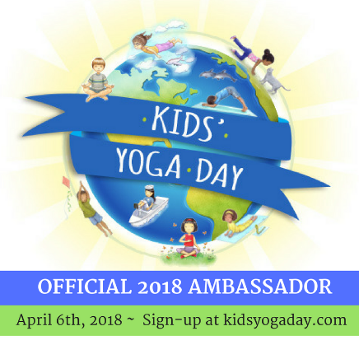
Now

Kids’ Yoga Day (KYD)
2018 Ambassador Checklist

- Join the Kids’ Yoga Day Ambassador Facebook group
- Bookmark kidsyogaday.com (FYI, visit our sister sites; worldyogapower.org and abcyogaforkids.com)
- Explore the KYD ambassador planning page, print out the 5 minute routines.
- Watch the Kids’ Yoga Day intro video
- Find a venue for your event (options include schools, yoga studios, parks, community centers, libraries, etc.)
- If needed, here’s a letter you can customize and send to your local principal
- Add the KYD Ambassador badge and your KYD event info to your website, Facebook page, Instagram etc.
- Invite friends / colleagues all over the world to hold their own KYD event. If 3 people sign up and mention your name, you’ll win a free copy of Teresa’s new board book, “My First Yoga ABC.”
- Consider becoming a Kids’ Yoga Day sponsor. Donations are tax-deductible and go towards helping Kids’ Yoga Day reach as many children as possible! It’s also a great way to get your name and company known.

February
- Create your event on Facebook, Eventbrite, etc. Need a FB Event image? Use this!
- Share your event info with us (via email or social media) and we’ll add it to our webpage.
- Watch the KYD instructional training video
- Plan your event – Will you provide food, drinks, etc.? Have special signage? Seek sponsors?

Beginning of March
- Advertise your event (here’s a sample flyer)
- Invite people via Facebook or other social media to your event
Mid-March
- Contact the local press using our customizable press release template. Make sure to check kidsyogaday.com for the most recent number of kids, states and countries participating.
- Listen to our recorded training call.
- Watch Teresa and friends walk through the routine.
- Obtain permission from parents to include KYD photos on social media. If needed, here is a release form.
- Share KYD prep on social media (use #kidsyogaday)
- Print Certificates of Participation for your little yogis on Kids’ Yoga Day
- Print fun feedback activity pages for your students to complete after Kids’ Yoga Day
Downloadable Activity Guide available for purchase at: http://bit.ly/2DX8Lo5
Sponsors: Individuals, companies or organizations interested in becoming a KYD sponsor, please email us!
We’re Kids’ Yoga Day on: Instagram, Facebook, Twitter
You can also sign up for free yoga tips and news from Kids’ Yoga Day founder, Teresa Power, at abcyogaforkids.com!
Other: If you need more instruction, all of the routines are based on Teresa Power’s award-winning books… More info here:

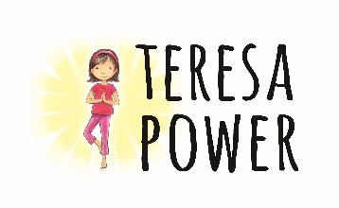
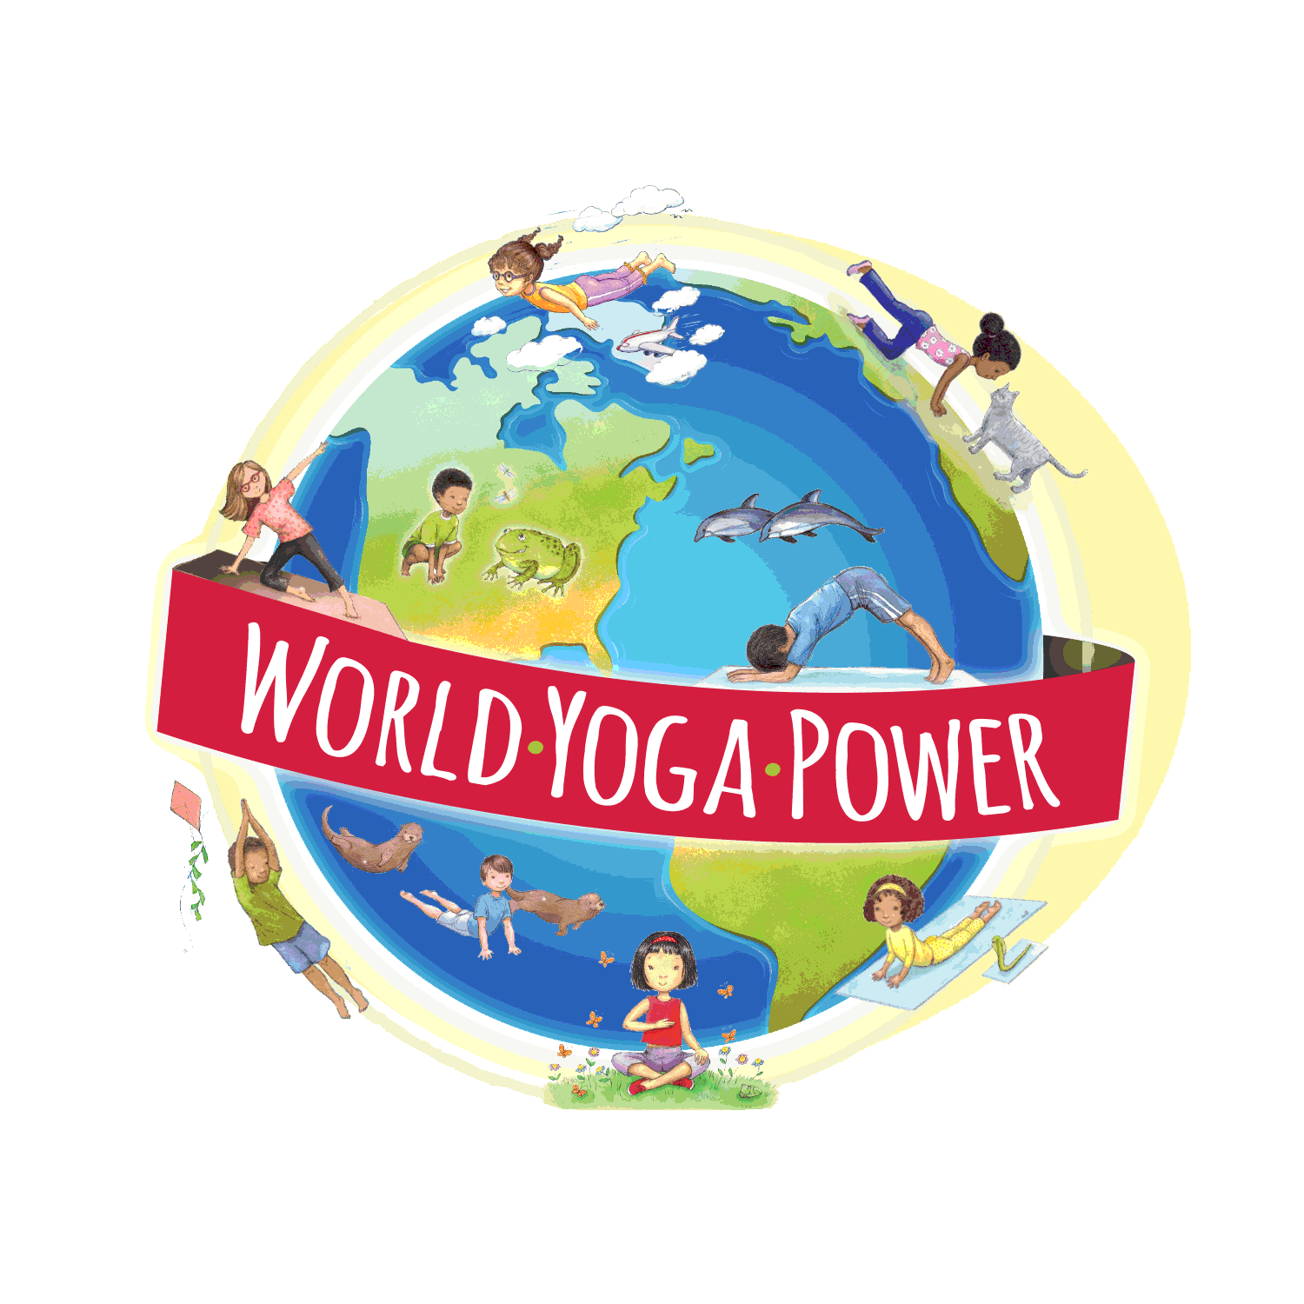
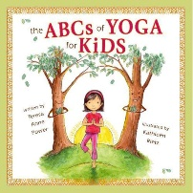
Kids’ Yoga Day is brought to you by Teresa Power, World Yoga Power
(a 501 (c)(3) organization) and the ABCs of Yoga for Kids.

